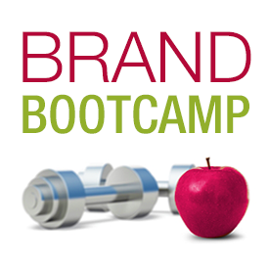

Red Slice Indie Brand Bootcamp
Homeplay Exercise Packet

Ready to tone up your brand? Jump inside!

Maria Ross
Founder & Chief Strategist, Red Slice, LLC
www.red-slice.com

This packet contains copyrighted material and is for the exclusive use of Red Slice Brand Bootcamp purchasers.

Welcome, friend!

A few ground rules, please…..

- Watch the videos for each module before diving into the exercises. They’ll make way more sense.

- Do the modules in order – each lesson builds upon the previous one.

- If you get stuck or have questions, please post to the private Facebook mentoring group Red Slice Brand Bootcamp (if you haven’t already, please request admission). Or shoot me an email at bootcamp@red-slice.com

Happy Branding!

BRAND AS FOUNDATION
Your Brand Strategy is dynamic – it lives, breathes and adapts and the details will refresh over time as you learn more about your customers, your market, or your offerings. But the core of it, the essence, vision and intent will form the foundation for all your other marketing and even operational decisions going forward.
Like a sturdy house, effective branding works from the bottom up. You can’t decide on room décor and paint until you have a strong foundation upon which to build the house in the first place. Having a clearly articulated brand strategy will make things a heck of a lot easier when it comes to making key decisions about your business – and it will help you attract rabid fans and achieve success!
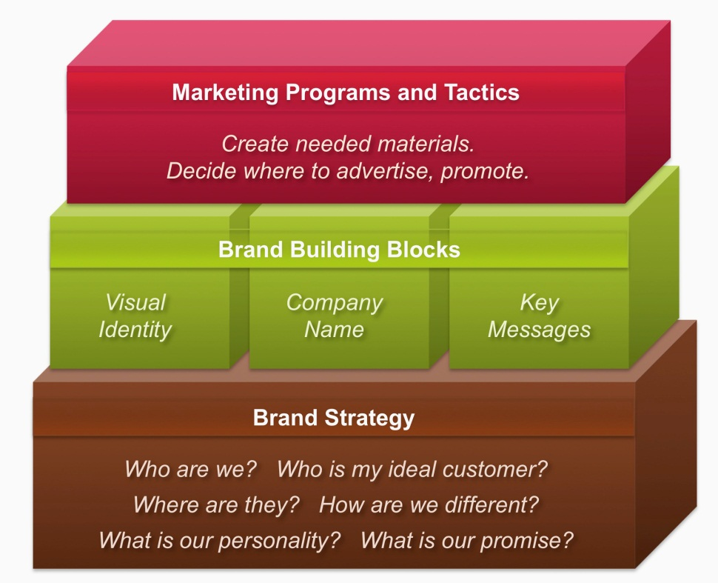

MODULE 1: WHAT IS BRAND?

WHAT DOES MY BUSINESS DO?

Literally, what do you do/offer? No marketing speak! You must start with defining this well and simply before embarking on brand strategy. Are you a product or service? Web-based or brick and mortar? Who do you serve?

Write down what you literally do/sell/provide and to whom in 2-3 concise sentences:

MODULE 2: BRAND MISSION AND GOALS

MISSION AND VISION

MISSION: What we aim to do on daily basis
Your mission statement is a precise definition of what your organization does on a daily basis and what you want to accomplish. It should describe the business you’re in and provide a definition of why the organization exists.
“Make flying good again” (Virgin America) “
Our mission: to inspire and nurture the human spirit– one person, one cup, and one neighborhood at a time.” (Starbucks)
”The mission of Southwest Airlines is dedication to the highest quality of Customer Service delivered with a sense of warmth, friendliness, individual pride, and Company Spirit.” (Southwest Airlines)
“To provide effective means for the prevention of cruelty to animals throughout the United States” (ASPCA)

My organization’s mission is to (use verbs if you can)

VISION: Why we do what we do. The person/company’s ideal preferred future
- Draws on the beliefs, mission, and environment of the organization
- Describe what you want to see in the future
- Be positive and inspiring
- Don’t assume the system will have the same framework as it does today
- Be open to dramatic modifications to current organization, methodology, teaching techniques, facilities, etc.

Ask yourself:
- Where will my company be in the long term?
- Will it be the premier provider of a particular product or service?
- Will it be in the top ten international players in a particular market?
- What is the ultimate “to-be” state for my company?

My organization’s vision is to be… or create a world in which:

VALUES

What is your business philosophy? What is important in running the business day by day in order to achieve the mission and vision? What do you want to be known for in terms of how you work? These could be basics values like Honesty, Trust and Transparency. You can also then explain what you mean by this value, for example: Trust – For our customers to trust us to deliver quality, we also trust them. This is why we never require a receipt for a return. If you’re not happy, we trust you and want to make things right.

I want my business and brand to live by the following values (list 5 to 7) and how I define them:

VALUE | DEFINITION/MESSAGE

BRAND GOALS

Which five to seven metrics do you want to measure to ensure your brand is on track and making an impact?

Great branding is a journey, not a destination. But you want to measure some key things and ensure they are trending upwards in a positive direction!

Sure, at the end of the day it’s all about sales but you have to take steps to get there. Just as you can’t propose on the first date, you need to build a brand over time so that it represents something clear and consistent to your target customers before they’ll lay down money for you. The steps to a sale are often called “the sales or marketing cycle”. Marketers will often call these phases: Awareness, Education, Consideration, and Purchase. Effective branding and messaging at each phase can help move your customers to the Purchase phase faster.

Try to keep your brand goals more aligned to increasing visibility, awareness or visits. Knowing about you and understanding what you offer is the first step required for an eventual purchase.

Remember, these can be quantitative or qualitative. It’s actually a good idea to use some of both, so you should record important anecdotal or general feedback you receive. Make your metrics realistic but time-based if you can, such as “20 new newsletter signups each month” or “50 attendees to each monthly event.” You can have one of the metrics be a sales number if you like, such as “Generate $2 million in revenue this quarter” but keep that as your ultimate objective — the one to which all your branding and marketing activities, with their individual goals, will lead.

My five main branding goals are:

METRIC: | WHERE I AM TODAY: | WHERE I WANT TO BE:

MODULE 3: IDEAL CUSTOMERS/CLIENTS

This is the single most important aspect to a strong Brand Strategy. If you don’t know your audience intimately and make them real, you’ll be shooting at a moving target. In defining your audience, think about your ideal customer, not your average customer. Articulating this also helps ensure your pricing and packaging appeals to the right person.

Who is your ideal customer? GET CREATIVE! If you sell to multiple customer segments, only choose up to three (i.e., “The Mompreneurs” or “The Tech-savvy Executives”)

SEGMENT TITLE | #1: The xxxx | #2:The yyyy | #3: The zzzz
What is his/her name:
Gender:
Where they live:
Age:
Occupation:
Family: (married? kids? single?)
Pets:
Passions/Interests/Hobbies:
Are they online? Which websites (work or play)
Do they read books? Which ones?
Do they watch TV? Which shows?
Do they read magazines? Which ones?
Do they eat at restaurants? Which ones?
What is their style of dress?
Places they shop?
Type of car/mode of transport?
Groups or associations they belong to?
They care about…
They despise…
They value…
They worry about…

Now, using this data, craft a narrative description for each person and find a royalty-free stock photo to represent him or her.

MODULE 4: MAKING YOUR BRAND STAND UP AND SHINE

STRENGTHS & WEAKNESSES

These are your corporate strengths and weaknesses, overall. What do you have in your arsenal from which to draw? Think of your business as a whole not necessarily product by product (unless there is a unique angle). Also, if you are a solo entrepreneur, consider your own personal strengths and weaknesses (networks, connections, experience, etc.)

STRENGTHS | WEAKNESSES

Look at this list. Think about how can you turn your weaknesses into strengths with your messaging? Brainstorm some ideas for how you might communicate your strengths visually, verbally or experientially?

BRAND ATTRIBUTES & PERSONALITY

What do you want people to associate your company with, or “think of” when they hear your name or see your logo? These are also known as brand attributes. Think of pictures, images, adjectives, famous people, locations, personality traits.

If your business was a person, what would they be like?

You might want to leverage the brands of people, characters, or locations for your description. As an example, in describing a brand as Audrey Hepburn, you would instantly get the picture of grace, femininity, elegance, and beauty without explicitly stating that. What images come to mind when you think of New York City as opposed to New Orleans?

This is a huge help to designers and writers in understanding your brand personality, tone and voice.

Brainstorm to create a list of all the adjectives, images, or emotions around your brand (the brand attributes) that come to mind first, and then trim the list until you have the 5-7 most crucial ones.

Some starter ideas:
Buttoned-up | Cutting-edge | Seasoned
Formal | Fast | Savvy
Casual | Calm | Cold
Down-to-Earth | Conservative | Bubbly
Natural | Snarky | Romantic
Practical | Humorous | Sober
Verbose | Cheesy | Adventurous
Frilly | Magical | Sleek
Fun | Serious | Shy
Angry | Manic | Trusted
Opulent | Luxurious | Approachable
Regal | Confident | Friendly
Geeky | Wise | Expert
Hand-crafted | Efficient | Convenient

These are the brand attributes that describe the personality and essence of my business:

Sometimes, analogies to other brands in other industries can work really well to encapsulate who you want your company to be and what you want to evoke that makes you stand out in your own industry:

My company should be the _____________________________ of my industry.

For example, if you look at cars, are you a Porsche, a Volvo wagon, or a Mini Convertible? (Or if not cars, you can use any category you enjoy such as restaurants, TV shows, celebrities, etc.)

COMPETITION

Your brand promise and messaging should clearly address how you’re different and why customers should come to you instead. Branding is all about differentiating your business from the other options customers have. Knowing what you’re up against will help you craft your message so you can clearly and concisely state why you’re the best alternative or the best use of budget dollars.

Identify 3-5 competitors to your business. Even if they are not direct competitors, include those indirect ones that a prospective client or customer may perceive as providing the same product or service as you do.

COMPETITOR | HOW ARE YOU THE SAME? | HOW ARE YOU DIFFERENT?

To help you fill in the above and perform this high-level competitive audit, as yourself these questions as you visit their websites

- Based on their visuals and copy, how does each competitor “position” itself in the market?

- Based on their visuals and copy, who do you think each competitor is going after as a target customer/client?

- Based on your answers above, is there “whitespace” for you to stake a claim? Is there a brand position, personality or target customer that no one is addressing that you could target to stand out and be different?

MODULE 5: CRAFTING A CLEAR, COMPELLING MESSAGE

BRAND MESSAGING PLATFORM (INTERNAL)
If you don’t have a good handle on how to verbalize the benefits you provide from the customer’s point of view, you won’t be able to build a brand that resonates both consciously and subconsciously with customers. The lack of benefits will leave all your marketing messages flat. Ideally, the features you cite will serve as proof for why you can make a certain benefit claim.

Start by identifying your three core benefits from the customer point of view first, create your messages and proof points and THEN roll that up into your Core Positioning Statement.

The three main benefits that customers or clients get from my products or services are:
BENEFIT (They get/increase/decrease/reduce/save/enjoy….) | EXPLANATION/CAPABILITY: (How do I deliver it to them?)

Next, roll up your benefits into your Core Positioning Statement:

My business offers __ (products/services) _____ for ____ (target audience) _______so they can _______________ (list each benefit) ________________________.

Now you’re ready to populate your Messaging Platform:

CORE POSITIONING STATEMENT GOES HERE:

BENEFIT: | BENEFIT: | BENEFIT:
EXPLANATION: | EXPLANATION: | EXPLANATION:
PROOF POINTS: WHY CAN YOU MAKE EACH BENEFIT CLAIM? HOW IS EACH ONE BACKED UP BY YOUR TRAINING, PHILOSOPHY, OFFERINGS, STATISTICS, AWARDS, EXCLUSIVITY OR CUSTOMER TESTIMONIALS?

- Xxx  - Yyy  - zzz | - xxx  - yyy  - zzz | - xxx  - yyy  - zzz
DIFFERENTIATORS: WHY YOU OVER COMPETITION? WHAT IS DIFFERENT ABOUT YOU THAT THEY CAN’T GET ANYWHERE ELSE?
- Xxx
- Yyy
- zzz

ELEVATOR PITCH

This is meant to be spoken, so ensure you use words that you would actually say or feel comfortable saying. This can evolve over time and adapt depending on the situation.

- Start with:

CORE POSITIONING STATEMENT:

______ offers __ (products/services) _____ for ____ (target audience) _______so they can _______________ (benefits) ________________________.

- Or put it into words you are comfortable saying out loud naturally or that have a little zip or pizzazz!

- Next, add a “bottom line:” a memorable “tag” or flair to the end: This could be your tagline, mission statement, or the analogy you came up with earlier (“Think of me as the Volvo of life coaches: comfortable, safe and reliable”)

- Wrap up by repeating your company name and URL

My Elevator Pitch:

MODULE 6: SEDUCING YOUR AUDIENCE WITH GREAT CONTENT

CONTENT MARKETING
To establish credibility, thought leadership and a viewpoint that differentiates your brand and adds value long before anyone spends a dime on you, you need to provide good content.
Content marketing is not just blogging, but also reports, videos, podcasts, social media updates and any other free content you provide to your audience. The goal is to offer value so they know, like and trust you in order to lead to a future sale. It helps build and reinforce your brand.
What are the problems people have or questions you always get asked about what you do? Pretend you’re a magazine: what articles would appear in your pages? Consider: trends, people, places, how-to tips, checklists, common myths/mistakes, books, movies, etc.
Determine 7-10 related content or topic areas around your industry, offering or products that you could address through blogs or guest articles on other sites/media.
TOPIC | RELATED SUBTOPICS

For one of these topics, brainstorm 3 - 4 posts for social media for it.

Facebook/Google+ Posts

Tweets:

Pinterest image ideas:

Now dream big: What are 2 grand content ideas that you might tackle in your plan to turn into a meatier eBook or a video series? Remember, think about topics that enable you to provide valuable content to your audience while softly selling your expertise and brand differentiation?

Concept/Theme | What Would it Look Like? Video series, gala event, training course, self-published book?
#1:
#2:

EDITORIAL CALENDAR

How do you best like to plan? By week, month, quarter? Create a calendar in Excel or Word and post the months across one row. For each month, determine an umbrella topic or theme you want to cover, and then come up with a blog post per week, related to that topic. Use your list above to help you with this.

Here’s a sample template for a one month time period for a nutrition coach:

JANUARY TOPIC: | Post-Holiday Hangovers and New Year’s Resolutions
 | Week 1 | Why New Year’s Resolutions Are Bad for Your Health
 | Week 2: | 4 Ways to Kick Your Sugar Habit This Year
 | Week 3: | Post-holiday Blues: The 3 Foods that May be Making you Sadder
 | Week 4 | 3 Killer Comfort Food Recipes that Won’t Pack on the Pounds

Once you create your editorial calendar, you can also start pre-writing social media posts, related to that topic and scheduling them with powerful tools like HootSuite and Tweetdeck. Even Facebook now allows you to pre-schedule posts on a business Fan Page.

I suggest building this in a separate spreadsheet to make your life easier!

MODULE 7: PUTTING YOUR BRAND STRATEGY INTO ACTION

BRAND STRATEGY CHECKLIST:
- Brand Strategy Document
  - Mission
  - Vision
  - Values
  - Brand Attributes
  - Brand Voice and Personality
  - Ideal Customer Profiles
  - Competitive Landscape
  - Benefits
  - Differentiators
  - Pricing/Packaging/Distribution Models
- Key Messages Document
  - Messaging Platform
  - 25, 50, 100 word company descriptors
  - 30-second elevator pitch
  - Press release boilerplate
  - Mission Statement
  - Vision Statement
  - Executive Bios
  - Tagline
  - Any specific words to use, and ones to avoid
- Visual Identity System/Brand Style Guide
  - Color palette with specific PMS, RGB, HEX and CMYK codes
  - Logo lock-ups and usage guidelines (color and B/W)
  - Font and typeface guidelines
  - Image library and guidelines (if any)
  - Any other specific Do’s and Don’ts for Usage

THE RULE OF THREE

The following is an excerpt from Maria Ross’s book, Branding Basics for Small Business: How to Create an Irresistible Brand on Any Budget (2010, Norlights Press).

When putting together your marketing plan, it’s important to know where your ideal buying audience goes. Try to be in those places. And so you don’t lose your sanity trying to promote and advertise everywhere, go deep rather than broad. By this I mean identify a few key publications, websites, or events that are exactly the right fit for you and create an integrated marketing package with each ad sales rep. Most small businesses don’t have the budget to do a lot of advertising and marketing in every single place their ideal customer might be. So pick a few partners and try to do as much as you can with each one, versus a one-time shot across many different vehicles.

I call this following the Rule of Three. In a given month or quarter, depending on your budget, focus on three publications, three website partners, three events, etc. Engaging in fewer activities, but more of the right ones, will be more effective for you than skipping a stone across the lake and barely making a splash with each marketing vehicle. For example, you might partner with a website that fits your audience profile and negotiate the following add-ons:
• A dedicated email to their subscriber base
• Exposure at an event or webcast they’re sponsoring
• Online ads in different forums over a three or six month period, rather than just once
• Permission to write an article or blog post on a brand-related topic.

Many ad sales reps are delighted to get creative and you can put a multi-touch or integrated marketing program in place to get your brand and promise in front of the right people multiple times and in multiple ways.

Magazines, radio stations, TV shows, websites, and events all have their own brand promise and attract certain audiences. If you know your brand well, you can confidently decide which ones align with your best possible customers, your values, and your benefits. The same holds true for deciding on partners. Yes, some distribution partners may give you access to millions of people you’d never be able to reach. But if none of those people will buy from you or be attracted to your brand promise, then that is just money and energy down the drain. You want to avoid partnering with firms that downgrade your brand or get you in front of people who won’t buy from you.

© Red Slice LLC. All other companies or works cited remain the copyright of their respective owners.

